**Autism VR Demo Detail Description**

1. Show tittle “Daily Living” as a header
2. In the category “Daily Living”, there are some topics, player can use controller to select the topic. It should look like the image below:

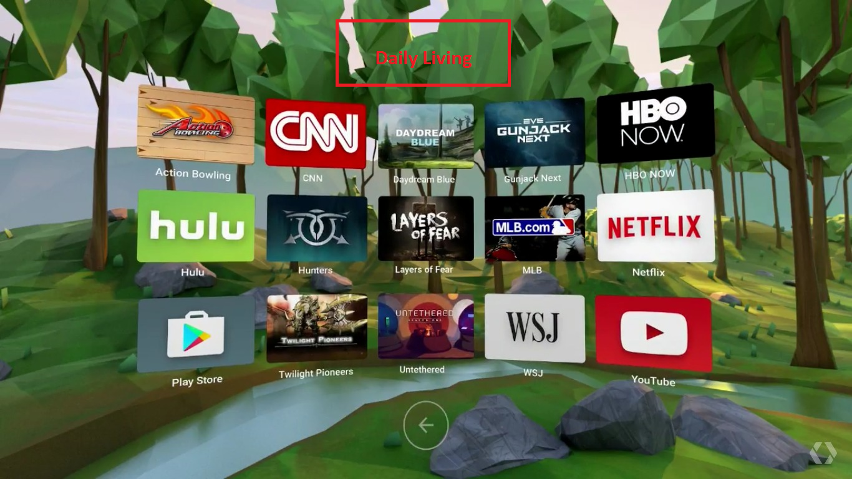

* Taking a shower -> click able
* Brushing my teeth
* **Using the restroom (Potty)**
* Having a breakfast
* Buying foods
* Washing my face
* Reading a book
* Watching tv
* Throwing waste

1. For now, player can only select “Using the restroom”, others titles/images are static UI and should not be clickable.
2. For “Use the restroom”, there are 16 steps:
   1. **Open**, **Enter**, and **Close** bath room door

* Show the text guide “Open the bathroom door” in front of the door
  + Highlight the door knob so that player know it is clickable/selectable
  + Player clicks/selects the door knob to **Open** the door
  + Show door open animation
  + Show the text guide “Well done! You have entered the restroom”
* Show the text guide “Now, please close the door.”
  + Highlight the door knob so that player know it is clickable/selectable
  + Show door close animation
  + Show message “Great, please proceed to the toilet bowl.”

Flash an animation and Increase/add 1 point, show total points somewhere in the page e.g. 1/7 points

* 1. Pull short/pant and underwear down
  + Hide the previous text guide
  + Move player to in front of toilet bowl
  + Show the text guide “Now, pull your short/pant and underwear down”
  + Highlight the **short/pant and underwear** so that player know it is clickable
  + Show animation to show player pulling short/pant and underwear down for 7-10 seconds
  + When the animation is done. Show the text guide “Good job! Let’s sit on the toilet bowl”

Flash an animation and Increase/add 1 point, show total points somewhere in the page e.g., 2/7 points

* 1. Using the toilet bowl
  + Hide the previous text guide
  + Show the text guide “Yeah, you are now ready to use the toilet”
  + Highlight the **Toilet bowl** so that player know it is clickable
  + Player click on the Toilet bowl
  + Show animation to show player using the toilet for 7-10 seconds
  + Hide the previous text guide
  + Show the text guide “Wonderful! I’m done!”

Flash an animation and Increase/add 1 point, show total points somewhere in the page e.g. 3/7 points

* 1. Get toilet paper and clean up
  + Hide the previous text guide
  + Show the text guide “Now, take a few pieces of the toilet paper”
  + Highlight the **toilet paper** so that player know it is clickable
  + Player clicks on the toilet paper to take it
  + Show taking the toilet paper animation
  + Show the text guide “Fantastic, you can use the toilet paper to wipe clean your backside”
  + Show animation to show player cleaning backside for 7-10 seconds
  + Show a button “When you are done, please click on the button”
  + Show the text guide “Great! I’m done!”

Flash an animation and Increase/add 1 point, show total points somewhere in the page e.g. 4/7 points

* 1. Pull underwear and short/pant up
  + Hide the previous text guide
  + Show the text guide “Now, pull your underwear and short/pant up”
  + Highlight the **short/pant and underwear** so that player know it is clickable
  + Show animation to show player pulling short/pant and underwear up for 7-10 seconds
  + Show the text guide “Great! Almost done”

Flash an animation and Increase/add 1 point, show total points somewhere in the page e.g. 5/7 points

* 1. Flush the toilet bowl
  + Hide the previous text guide
  + Show the text guide “Now, flash the toilet bowl”
  + Player puts/points his hand (controller) at the flashing area
  + Highlight the flashing area so that player know it is clickable/selectable
  + Once clicked, show simple animation of flashing and show the text guide “Wonderful! You have successfully flashed it!”

Flash an animation and Increase/add 1 point, show total points somewhere in the page e.g. 6/7 points

* 1. Go to the sink
  + Animation, Move player to the sink area
  + Hide the previous text guide
  + Show text guide “Now, let’s turn on the tap and wash your hand”
  + Highlight the tap, so that player know it is clickable
  + Player clicks on the tap
  + Show text guide “Good! Now apply liquid soap”
  + Highlight the liquid soap, so that player know it is clickable
  + Player clicks on the Liquid soap
  + Once clicked, show simple animation of washing and show the text guide “Yeah! It is clean now.”
  + Show text guide “Now, let’s turn off the tap and wipe your hand”
  + Highlight the tap, so that player know it is clickable
  + Once clicked, show simple animation of tap is turned off and show the text guide

Flash an animation and Increase/add 1 point, show total points somewhere in the page e.g. 7/7 points

* 1. DONE

1. Player need to complete all the steps in a topic to process to next topic. For now, we only have 1 topic which is “Take a shower”.
2. There is text guide box for each step the player need to do, player will follow the guide to complete all the steps. The text guide is a textbox with an arrow to attract player attention.

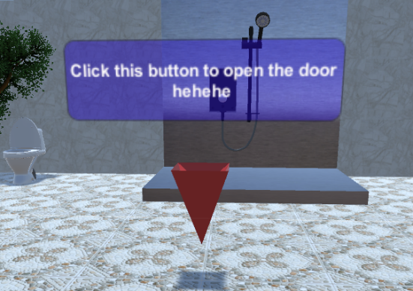

1. After player completed the topic, show it as completed with some starts as the result. We can skip this for this demo.